**CONTENTS**

| **Expt. No** | **Date** | **Title of Experiment** | **Page** | **Signature** |
| --- | --- | --- | --- | --- |
| 1 |  | Install Guest OS on that VMWARE |  |  |
| 2 |  | Shrink and extend virtual disk |  |  |
| Create, Manage, Configure and schedule snapshots |
| Create Spanned, Mirrored and Striped volume |
| Create RAID 5 volume |
| 3 |  | Desktop Virtualization using VNC |  |  |
| Desktop Virtualization using Chrome Remote Desktop |
| 4 |  | Create type 2 virtualization on ESXI 6.5 server |  |  |
| 5 |  | Create a VLAN in CISCO packet tracer |  |  |
| 6 |  | Install KVM in Linux |  |  |
| 7 |  | Create Nested Virtual Machine(VM under another VM) |  |  |

**Ex.1:** Create type 2 virtualization in VMWARE or any equivalent Open Source Tool. Allocate memory and storage space as per requirement. Install Guest OS on that VMWARE

**Aim:**

To find the procedure to run VM of different configuration and Allocate memory and storage space as per requirement **.**

**Procedure:**

**Step 1:** Download and Install VMware Workstation Player

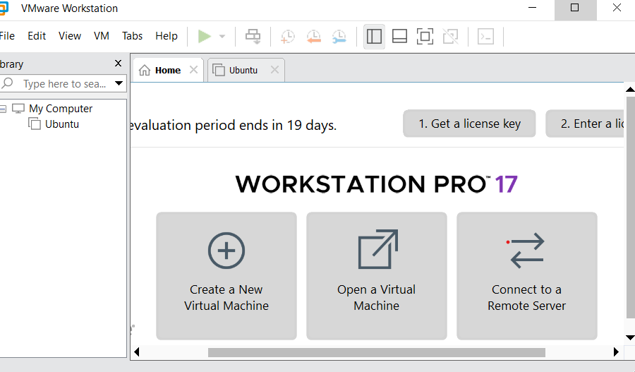

**Step 2:** Create a New Virtual Machine

Open VMware Workstation Player

Click on "Create a New Virtual Machine" or go to File > New Virtual Machine

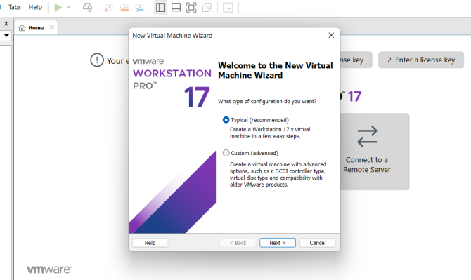

**Step 3:** Virtual Machine Configuration Wizard

The Virtual machine configuration Wizard will appear. Choose “Typical” configuration and click “Next”.

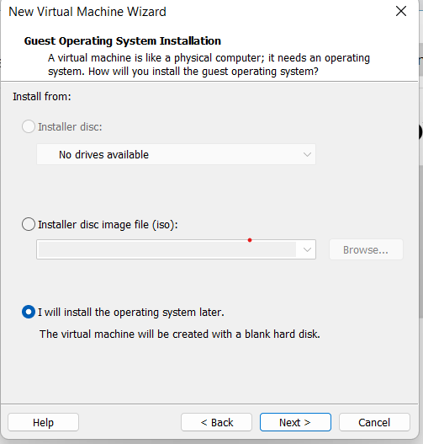

**Step 4:** Install Guest Operating System

* Choose the installation method for the guest OS. You can either install from a disc or image file (ISO) or choose to install later. If you have the ISO file for your guest OS, select it during this step
* Click “Next”

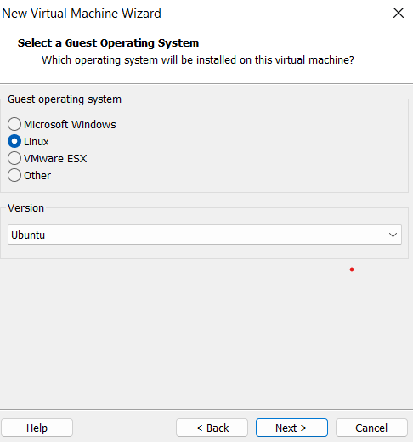

**Step 5:** Enter Guest OS Details

* Enter the name of your virtual machine and choose the location where you want to save it.
* Select the appropriate guest operating system and version. For example, if you are installing Windows 10, choose "Windows" as the guest OS and "Windows 10 x64" as the version.
* Click "Next."

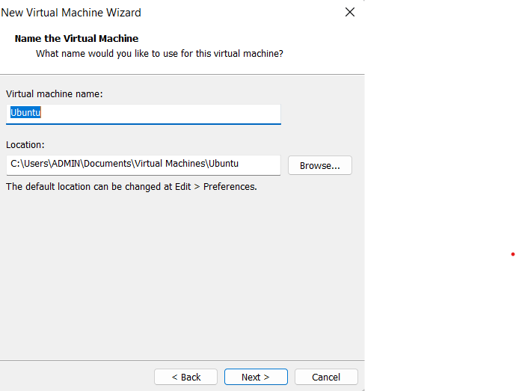

**Step 6:** Configure Virtual Machine Hardware

* Allocate memory: Choose how much RAM you want to allocate to the virtual machine. Make sure to leave enough memory for your host OS to run smoothly as well.
* Allocate storage: Choose whether to store the virtual disk as a single file or split into multiple files. Specify the disk size, and you can also choose to allocate all disk space now or let it grow as needed.
* Click "Next."

**Step 8:**  Customize Hardware (Optional)

* If needed, you can customize the virtual machine's hardware settings like CPU cores, network adapters, graphics memory, etc. Otherwise, you can leave them as default.
* Click "Finish" once you are satisfied with the settings.

**Step 8:** Install Guest OS

* Start the virtual machine you just created. The virtual machine will boot from the ISO or installation media you provided earlier.
* Follow the standard installation process for your guest OS.

**Step 9:** Install VMware Tools (Optional but Recommended)

* After installin/ g the guest OS, it is advisable to install VMware Tools within the guest OS. VMware Tools provides better integration between the host and guest OS, enabling features like shared folders, improved graphics, and more.

In the same way, we can install windows OS also. The output screens for the virtual machines of different configurations.

**OUTPUT:**

(i)Ubuntu Operating System in Virtual Machine

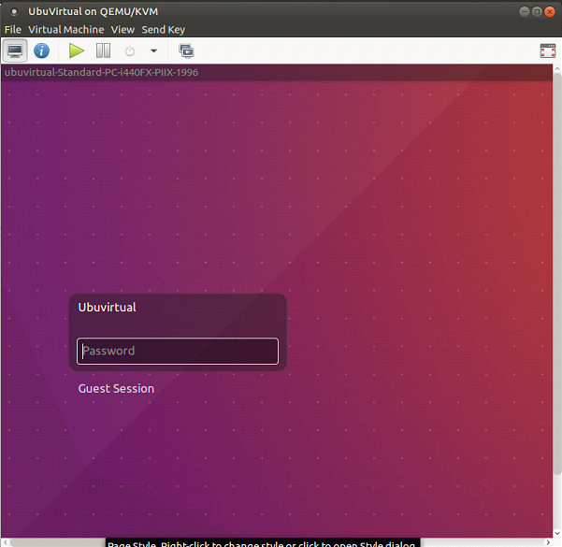

(ii)Windows7 Operating System in Virtual Machine

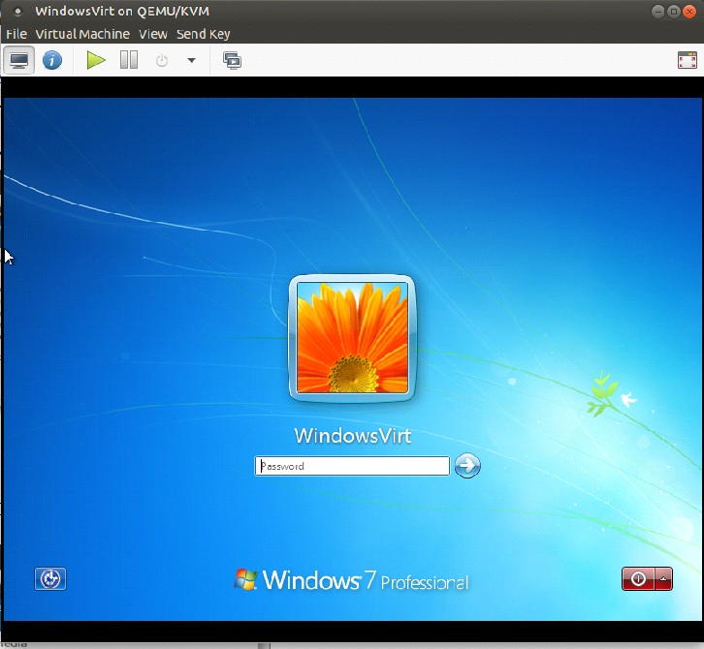

**RESULT:**

Thus, various configurations of Virtual machines has been created and run.**Ex 2(a): Shrink and Extend Virtual Disk**

**Aim:**

To find the procedure of Shrink a virtual disk involves reducing its size to reclaim unused space and extend a virtual disk allows you to increase its size to accommodate more data.

**Procedure:**

**Shrink a Virtual Disk:**

**Step1:** Inside the virtual machine, delete unnecessary files and empty the recycle bin/trash to free up space.

**Step 2:** Defragment the virtual machine's disk to move all the data to the beginning of the disk.

**Step 3:** Shutdown the virtual machine.

**Step 4:** On the host system, open the virtualization software

**Step 5:** Navigate to the virtual machine's settings or configuration.

**Step 6:** Select the virtual disk you want to shrink.

**Step 7:** Look for an option to shrink or compact the disk and follow the prompts.

**Step 8:** The process might take some time, and it's essential to back up your virtual machine before proceeding, as data loss can occur in some cases.

**Extend Virtual Disk:**

**Step 1**: Shutdown the virtual machine.

**Step 2:** On the host system, open the virtualization software (e.g., VMware, VirtualBox).

**Step 3:** Navigate to the virtual machine's settings or configuration.

**Step 4:** Select the virtual disk you want to extend.

**Step 5:** Look for an option to increase or extend the disk and follow the prompts.

**Step 6:** Specify the new size for the virtual disk (make sure to allocate enough space for your needs).

**Step 7:** The process might take some time, and it's crucial to back up your virtual machine before proceeding, as extending the disk involves modifying the underlying file system.

**Output:**

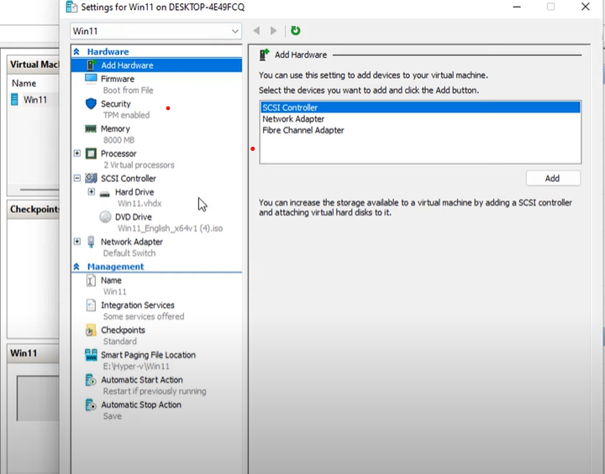

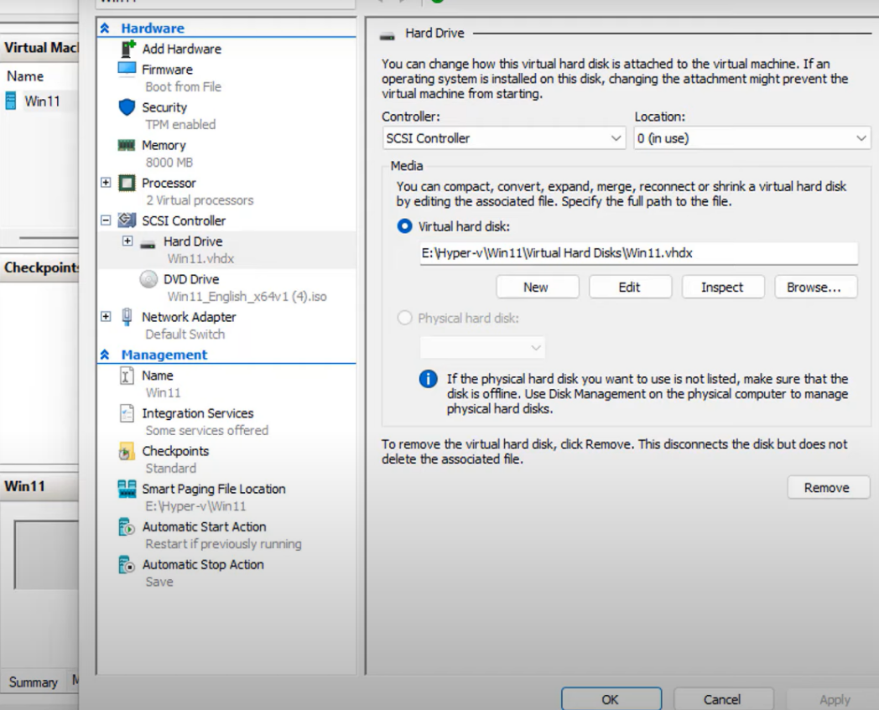

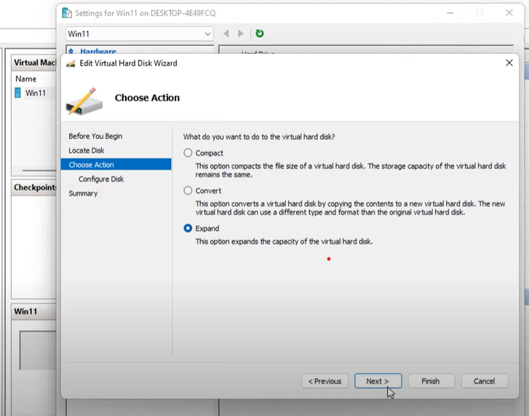

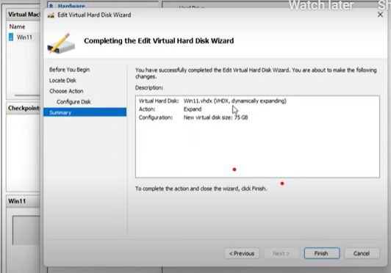

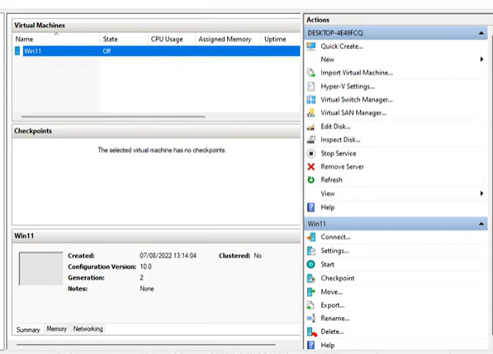

**Result:**

Thus, the shrink and extend of virtual disk has been created and run

Successfully.

**Ex 2(b): Create, Manage, Configure and schedule snapshots**

**Aim:** To find the procedure of Creating, managing, configuring, and scheduling snapshots is a fundamental part of virtual machine management.

**Procedure:**

**Step 1:** Creating a Snapshot: To create a snapshot, follow these steps:

a. Select the virtual machine in the management interface (e.g., vSphere Client).

b. Right-click on the virtual machine and choose "Snapshot" or "Take Snapshot."

c. Provide a name and description for the snapshot.

d. Optionally, select the memory state to capture the virtual machine's running state (requires the virtual machine to be powered off).

e. Click "OK" to create the snapshot.

**Step 2:** Managing Snapshots: Managing snapshots involves tasks such as viewing, reverting, deleting, and consolidating snapshots.

a. Viewing Snapshots: To see the list of snapshots for a virtual machine, navigate to the "Snapshots" tab in the virtual machine's details.

b. Reverting to a Snapshot: To revert a virtual machine to a specific snapshot, right-click on the snapshot and choose "Revert to Snapshot." This action will roll back the virtual machine to the state captured in the selected snapshot.

c. Deleting Snapshots: To delete a snapshot, right-click on the snapshot and choose "Delete Snapshot." You can choose to delete the snapshot only or delete the snapshot and consolidate its changes into the base virtual machine disk.

d. Consolidating Snapshots: If you have multiple snapshots, you can perform a "Snapshot Consolidation" to merge all snapshots into the base disk. This helps to reduce storage requirements and improves performance.

**Step 3:** Configuring Snapshot Settings: The snapshot settings allow you to define how snapshots are managed and stored.

a. Snapshot Location: Configure the location where snapshot files are stored, which can be on the same data store as the virtual machine or on a different storage location.

b. Snapshot Quiescent: Enable or disable the use of VMware Tools to quiesce the file system inside the virtual machine before taking a snapshot. This helps ensure application consistency during the snapshot.

**Step 4:** Scheduling Snapshots: Some virtualization platforms allow you to schedule snapshots to be taken automatically at specific intervals.

1. Scheduled Snapshots: Navigate to the virtual machine's settings, find the "Snapshot Schedule" option, and configure the frequency and retention policy for automatic snapshots.

**Output:**

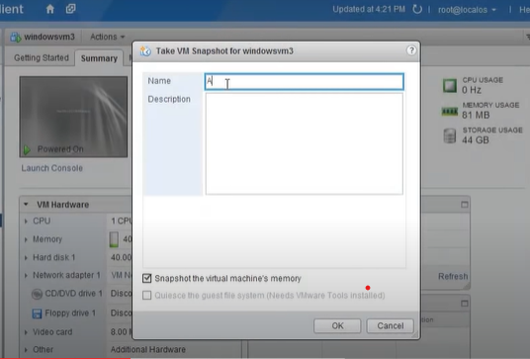

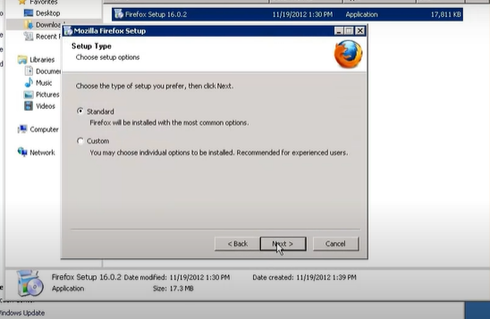

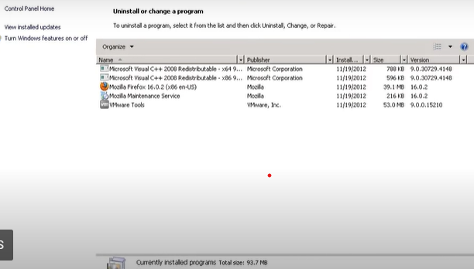

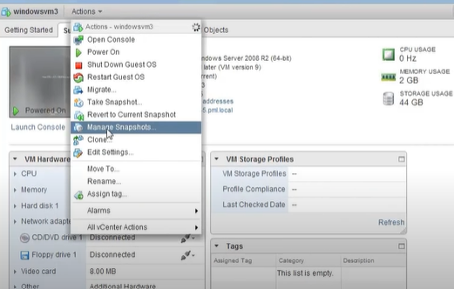

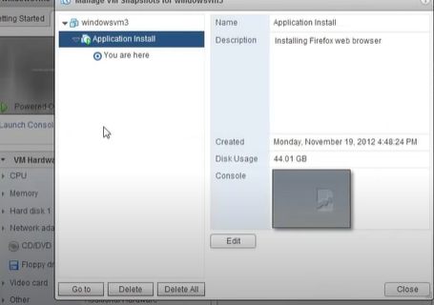

**Result**:

**Ex.3(a) Create Spanned, Mirrored and Striped volume**

**Aim:**

**Procedure :**

Step 1: How to create a spanned volume:

a. Right-click on "This PC" or "My Computer" and select "Manage."

b. In the Computer Management window, click on "Disk Management" under "Storage" in the left pane.

c. Identify the disks you want to use in the spanned volume. They should be unallocated or have empty space available.

d. Right-click on the first disk and choose "New Spanned Volume."

e. Follow the on-screen instructions to select additional disks and allocate space for the spanned volume.

f. Assign a drive letter or mount point to the new volume and format it with a file system.

Step 2: How to create a mirrored volume:

a. Follow steps a to c from the spanned volume creation process to open Disk Management.

b. Right-click on one of the disks you want to use in the mirror and choose "New Mirrored Volume."

c. Select the additional disk(s) to mirror the first disk, and then allocate space for the mirrored volume.

d. Assign a drive letter or mount point to the new volume and format it with a file system. e. Windows will start the synchronization process, where data is copied from the source disk to the mirror disk(s).

Step 3: How to create a striped volume:

a. Follow steps a to c from the spanned volume creation process to open Disk Management.

b. Right-click on one of the disks you want to use in the stripe and choose "New Striped Volume."

c. Select the additional disk(s) to include in the stripe, and then allocate space for the striped volume. d. Assign a drive letter or mount point to the new volume and format it with a file system.

**Output:**

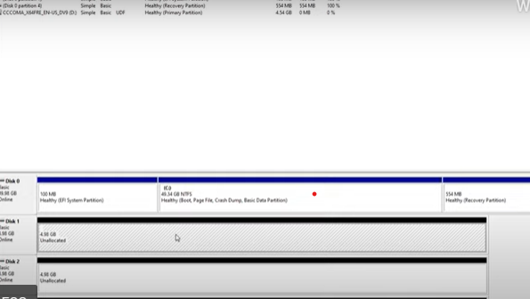

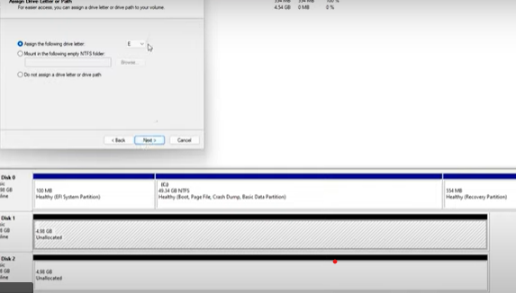

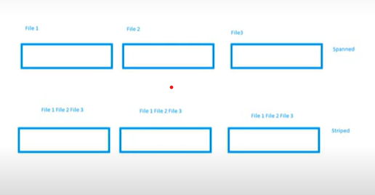

**Result:**

**Ex.3(b): Create RAID 5 Volume:**

**Aim:**

**Procedure:**

Step 1: Backup Data: Before creating the RAID 5 volume, back up all your critical data to ensure it is safe in case of any unforeseen issues.

Step 2: Initialize and Convert Disks to Dynamic: If your disks are currently basic disks, you need to convert them to dynamic disks to create a RAID 5 volume. Follow these steps:

a. Right-click on "This PC" or "My Computer" and select "Manage."

b. In the Computer Management window, click on "Disk Management" under "Storage" in the left pane.

c. Identify the disks you want to use in the RAID 5 array. They should be unallocated or have empty space available.

d. Right-click on each disk and select "Convert to Dynamic Disk." Repeat this for all the disks you want to include in the RAID 5 array.

Step 3: Create the RAID 5 Volume: Once you have converted the disks to dynamic, you can proceed to create the RAID 5 volume:

a. Right-click on one of the disks you want to use in the RAID 5 array.

b. Select "New Spanned Volume."

c. Follow the on-screen instructions to select the other disks you want to include in the RAID 5 array. There should be at least three disks in total.

d. Allocate the desired amount of space for the RAID 5 volume. RAID 5 requires a minimum of three disks, and the volume size will be the total capacity of all disks minus one disk's worth of space. For example, if you have three 1TB disks, the RAID 5 volume will have a total capacity of 2TB.

e. Assign a drive letter or mount point to the new RAID 5 volume and format it with a file system.

Step 4: Initialize and Format the RAID 5 Volume: After creating the RAID 5 volume, you need to initialize and format it:

a. When prompted, initialize the disks using the default partition style (usually GPT).

b. Format the RAID 5 volume with your desired file system (e.g., NTFS) and assign a drive letter or mount point.

Output:

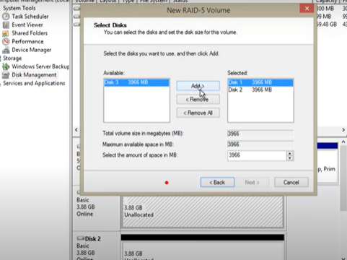

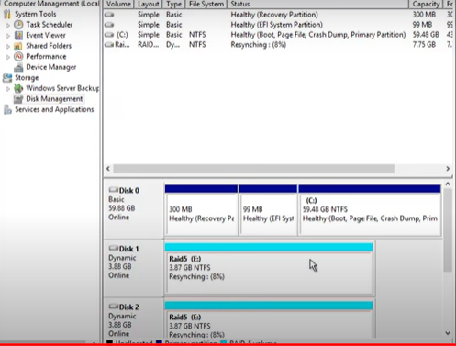

**Result:**

**Ex.4(a): Desktop Virtualization using VNC**

**Aim:**

**Procedure:**

**Step 1:** Install VNC Server.

**Step 2:** Configure VNC Server: After installing the VNC server, you'll need to configure it by setting a password or access control options to secure the remote access. Ensure that the VNC server is running and ready to accept incoming connections.

**Step 3:** Install VNC Viewer.

**Step 4:** Connect to the Remote Desktop: Launch the VNC viewer and enter the IP address or host name of the remote computer (the host) you want to connect to. If you have configured a password or access control options on the VNC server, you will be prompted to enter the credentials. Once authenticated, the VNC viewer establishes a connection to the remote desktop.

Step 5: Control the Remote Desktop: After the connection is established, you will see the remote desktop environment displayed in the VNC viewer. You can now interact with the remote desktop as if you were physically sitting in front of it. You can run applications, access files, and perform any tasks on the remote computer just as if you were using it directly.

**Output:**

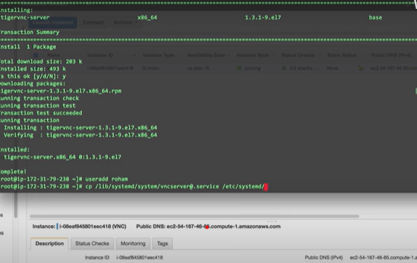

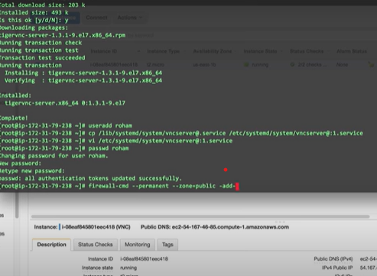

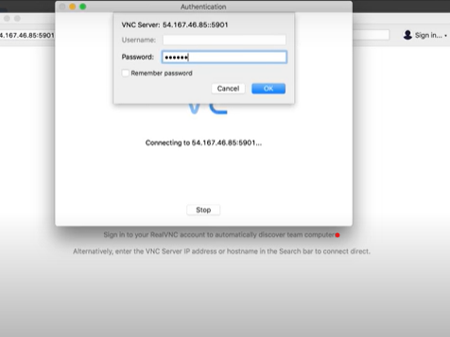

**Result:**

**Ex.4(b) Desktop Virtualization using Chrome Remote Desktop**

**Aim:**

**Procedure:**

**Step 1:** Install Chrome Remote Desktop Extension: Make sure you have the Google Chrome web browser installed on both the computer you want to access remotely (the host) and the computer or device you want to use for remote access (the client). Install the "Chrome Remote Desktop" extension from the Chrome Web Store on both devices.

**Step 2:** Set Up Host Computer (Computer to be Accessed):

a. Open Google Chrome on the host computer.

b. In the address bar, type "chrome://apps" and press Enter.

c. Click on the "Chrome Remote Desktop" icon to open the application.

d. Follow the on-screen instructions to grant necessary permissions and set up remote access for the host computer.

e. Create a secure PIN to use for remote access authentication.

**Step 3:** Access Host Computer (Client Device):

a. Open Google Chrome on the client device (the computer or device from which you want to access the host computer remotely).

b. In the address bar, type "remotedesktop.google.com/access" and press Enter.

c. Click on the "Access" button under the "Remote Access" section.

d. Sign in with your Google Account (the same account used on the host computer).

**Step 4:** Choose the Host Computer:

a. After signing in, you should see a list of available computers set up for remote access. Choose the host computer you want to access.

**Step 5:** Authenticate and Connect:

a. If you have set up a PIN for the host computer, you will be prompted to enter it to authenticate the remote access.

b. Once authenticated, the remote connection will be established, and you will see the host computer's desktop in the Chrome browser window.

**Step 6:** Control the Host Computer:

a. You can now interact with the host computer's desktop through the Chrome browser on your client device. Use your mouse and keyboard to control the remote desktop.

b. To switch between full-screen and windowed mode, click the "Toggle full screen" button on the top right corner of the remote desktop window.

**Step 7:** End the Remote Session: To end the remote session, click the "Stop Sharing" button at the bottom of the remote desktop window.

**Output:**

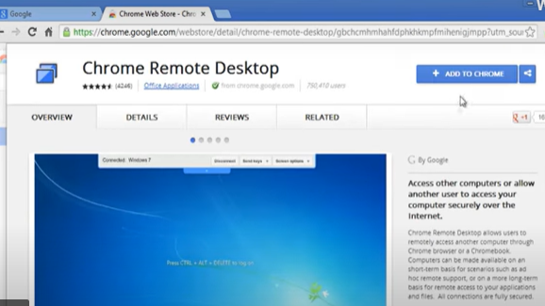

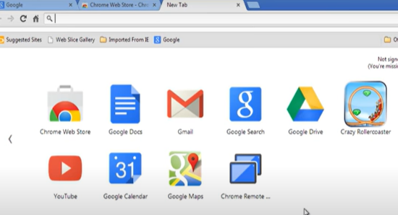

**Result:**

**Ex.5 Create type 2 virtualization on ESXI 6.5 server**

**Aim:**

**Procedure:**

**Step 1:** Install ESXi 6.5: First, you need to install VMware ESXi 6.5 on your server.

**Step 2:** Access ESXi Web Client: Once ESXi is installed and running, access the ESXi Web Client through a web browser on a separate computer. Enter the IP address or hostname of your ESXi server to log in to the management interface.

**Step 3:** Create a Virtual Machine: To create a virtual machine within ESXi, follow these steps:

a. In the ESXi Web Client, navigate to the "Hosts and Clusters" view.

b. Select your ESXi server from the list of hosts.

c. Click on the "Create/Register VM" button or right-click on the host and choose "New Virtual Machine."

d. The "Create New Virtual Machine" wizard will appear. Follow the steps in the wizard to configure the virtual machine, including providing a name, selecting the guest operating system, setting the desired resources (CPU, memory, disk space, etc.), and selecting a storage location for the virtual machine files.

e. Finish the wizard, and the virtual machine will be created.

**Step 4:** Install Guest Operating System: Once the virtual machine is created, you can power it on and install the guest operating system of your choice (e.g., Windows, Linux, etc.) using an ISO image or CD/DVD.

**Step 5:** Access and Manage the Virtual Machine: After the guest operating system is installed, you can access the virtual machine through the VMware Remote Console (VMRC) or use remote access tools like VNC or RDP to interact with the guest operating system.

**OUTPUT:**

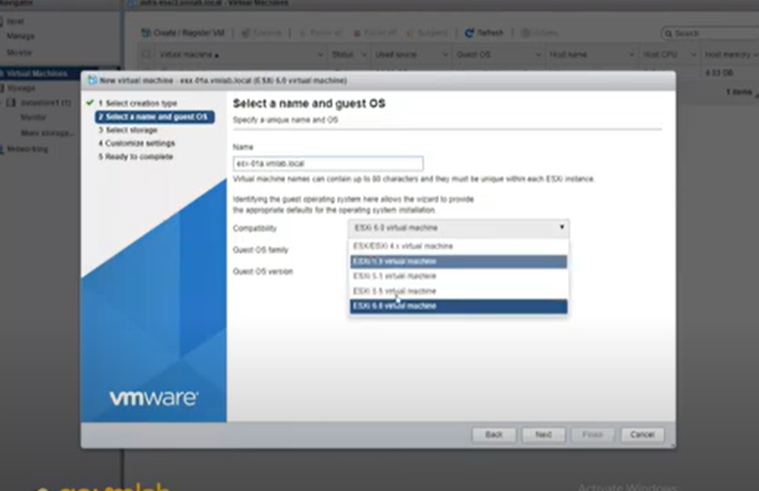

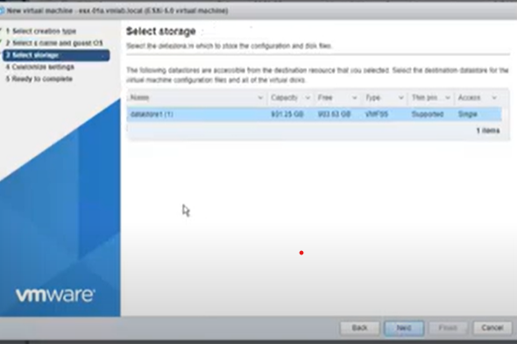

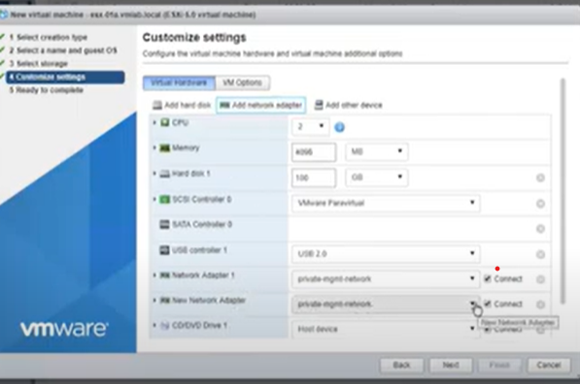

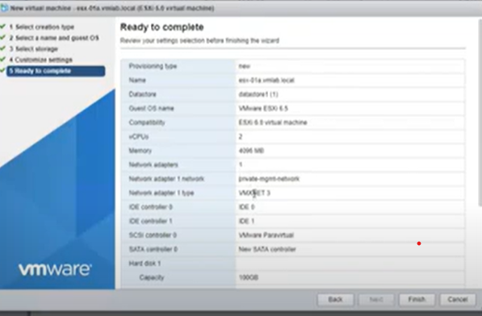

**Result:**

**Ex.6:** **Create a VLAN in CISCO packet tracer**

**Aim:**

**Procedure:**

**Step 1:** Launch Cisco Packet Tracer: Start Cisco Packet Tracer and open a new or existing project.

Step 2: Add Switches: Drag and drop switches from the "Switches" section of the "Devices" pane onto the workspace. You can use any Cisco switch model available in Packet Tracer.

**Step 3:** Connect Switches: Connect the switches using Ethernet cables. Click on the Ethernet interfaces of the switches and then click on the other switch's Ethernet interfaces to create connections.

**Step 4:** Access the CLI: Double-click on the first switch to access its CLI (Command Line Interface). The CLI window will open.

**Step 5:** Configure VLANs: Enter the configuration mode by typing the following command:

**enable**

**configure terminal**

**Step 6:** Create VLANs: To create VLANs, use the **vlan** command followed by the VLAN number. For example, to create VLAN 10 and VLAN 20, you would do:

**vlan 10**

**vlan 20**

**Step 7:** Assign Ports to VLANs: To assign ports to VLANs, use the

**interface** command followed by the port number and then the **switchport access vlan** command. For example, to assign port 1 to VLAN 10 and port 2 to VLAN 20, you would do:

interface FastEthernet0/1

switchport mode access

switchport access vlan 10

interface FastEthernet0/2

switchport mode access

switchport access vlan 20

**Step 8:** Exit Configuration Mode: After assigning VLANs to the desired ports, exit the configuration mode by typing **exit**.

**Step 9:** Save Configuration: Save the configuration by typing **write** or **copy running-config startup-config** to make sure the changes are saved.

**Step 10:** Test VLANs: Now that you have created VLANs and assigned ports, you can test the connectivity between devices connected to the switches. Devices in the same VLAN should be able to communicate with each other, while devices in different VLANs should not have direct communication unless you configure inter-VLAN routing.

Output:

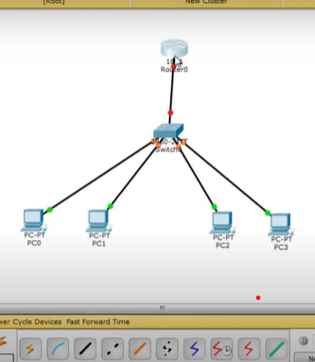 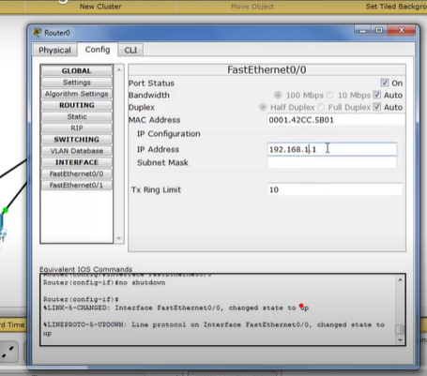

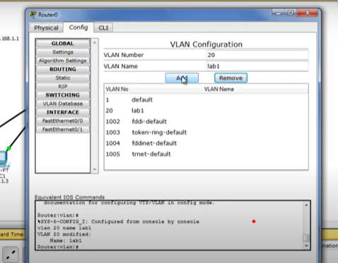 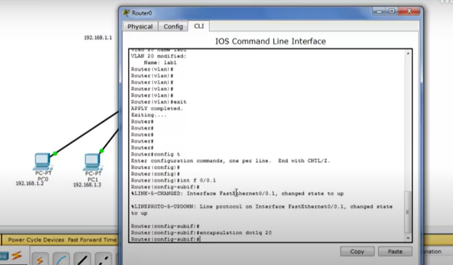

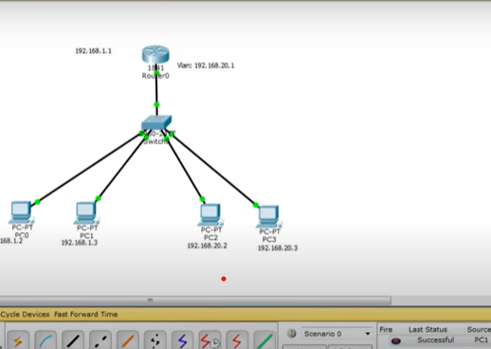

**Result**:

**Ex.7. Install KVM in Linux**

**Aim:**

**Procedure:**

**Step 1:** Check Hardware Support: Before installing KVM, ensure that your system's CPU supports hardware virtualization extensions (Intel VT-x or AMD-V). You can check this by running the following command:

**egrep -c '(vmx|svm)' /proc/cpuinfo**

If the output is greater than zero (1 or more), it means your CPU supports hardware virtualization.

**Step 2:** Install KVM Packages: The package names may vary depending on your Linux distribution. Here are the package names for some popular distributions:

For Ubuntu/Debian:

**sudo apt update**

**sudo apt install qemu-kvm libvirt-daemon-system libvirt-clients bridge-utils virt-manager**

For CentOS/RHEL:

**sudo yum install qemu-kvm libvirt virt-install bridge-utils**

**sudo systemctl enable libvirtd**

**sudo systemctl start libvirtd**

For Fedora:

**sudo dnf install @virtualization**

**sudo systemctl enable libvirtd**

**sudo systemctl start libvirtd**

**Step 3:** Verify Installation: After installing the required packages, check if KVM kernel modules are loaded correctly:

**lsmod | grep kvm**

The output should show **kvm** and **kvm_intel** or **kvm_amd** modules loaded, depending on your CPU.

**Step 4:** Configure Permissions: For non-root users to manage virtual machines using KVM, add them to the **libvirt** group:

**sudo usermod -aG libvirt <username>**

Remember to log out and log back in for the changes to take effect.

**Step 5:** Enable Nested Virtualization (Optional): If you plan to run virtual machines with nested virtualization (e.g., running KVM inside a KVM guest), you may need to enable nested virtualization on the host. This step is only required if you intend to run virtual machines with KVM as guests.

For Intel CPUs:

**echo "options kvm-intel nested=1" | sudo tee /etc/modprobe.d/kvm-intel.conf**

**sudo modprobe -r kvm_intel**

**sudo modprobe kvm_intel**

For AMD CPUs:

**echo "options kvm-amd nested=1" | sudo tee /etc/modprobe.d/kvm-amd.conf**

**sudo modprobe -r kvm_amd**

**sudo modprobe kvm_amd**

**Step 6:** Install and Configure Virt-Manager (Optional): Virt-Manager is a graphical user interface tool to manage virtual machines using KVM. If you prefer a GUI interface, you can install Virt-Manager:

For Ubuntu/Debian:

**sudo apt install virt-manager**

For CentOS/RHEL:

**sudo yum install virt-manager**

For Fedora:

**sudo dnf install virt-manager**

Once the installation is complete, you can start creating and managing virtual machines using KVM. You can use command-line tools like **virsh** or a graphical interface like Virt-Manager to interact with KVM.

**Output:**

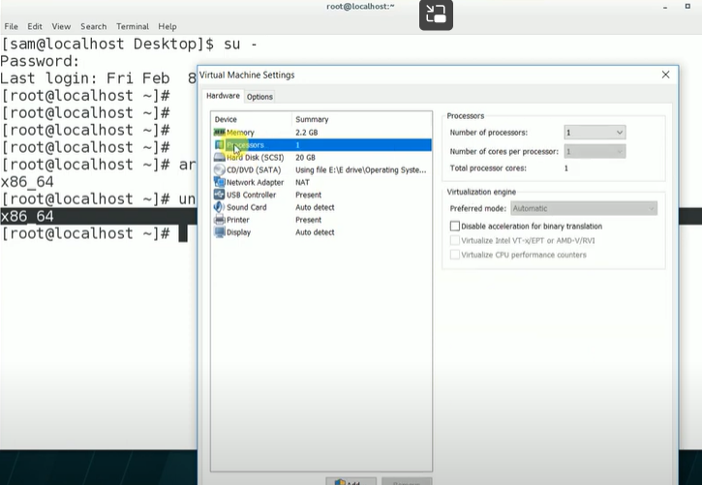

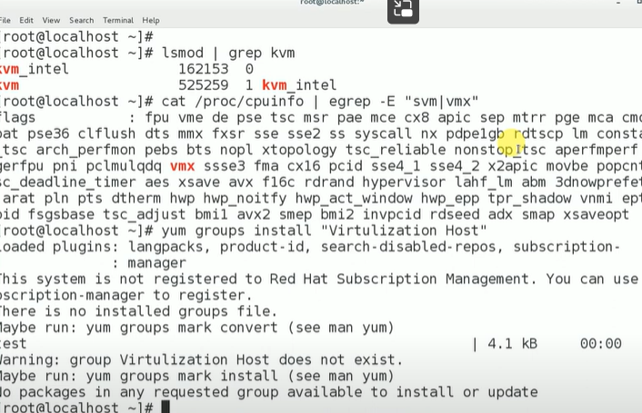

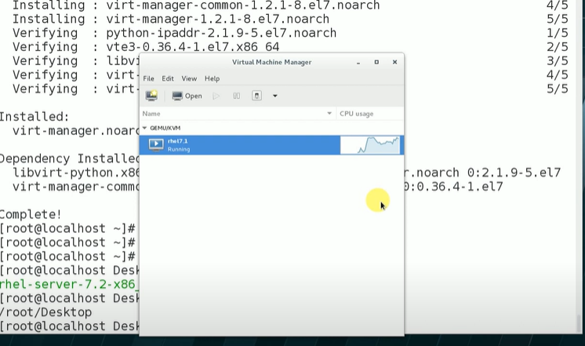

**Result:**

**Ex.8: Create Nested Virtual Machine(VM under another VM)**

**Aim:**

**Procedure:**

**Step 1:** Enable Nested Virtualization: Before creating a nested VM, ensure nested virtualization is enabled on the host VM (the VM that will run other VMs).

For VirtualBox:

Open VirtualBox and select the host VM from the list. Go to "Settings" > "System" > "Processor" and check the "Enable Nested VT-x/AMD-V" option.

**Step 2:** Install an Operating System in the Host VM: Ensure you have an operating system installed in the host VM. This will be the environment in which you'll run the nested VMs.

**Step 3:** Install VirtualBox within the Host VM: Inside the host VM, download and install VirtualBox (or any other virtualization software you prefer) as if you were installing it on a physical machine.

**Step 4:** Create the Nested VM: Now that you have VirtualBox installed within the host VM, you can create a new VM inside it.

a. Open VirtualBox within the host VM.

b. Click on "New" to create a new VM.

c. Follow the VM creation wizard to set up the nested VM, including selecting the guest operating system, allocating memory, creating a virtual hard disk, etc.

**Step 4:** Install the Guest Operating System in the Nested VM: With the nested VM created, start it and install the guest operating system, just as you would with any regular VM installation.

**Step 5;** Configure Networking (Optional): Depending on your requirements, you may need to configure the networking of the nested VM to allow communication with other VMs or external networks.

**Step 6:** Use the Nested VM: Once the nested VM is set up and the guest operating system is installed, you can use it just like any other VM. Install applications, run tests, or perform any tasks within the nested VM.

**Output:**

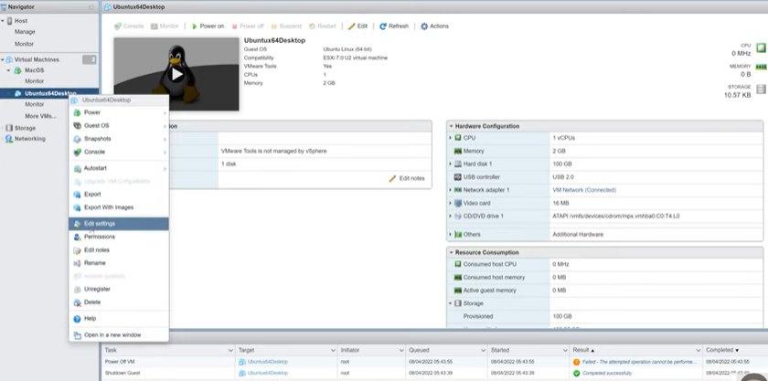

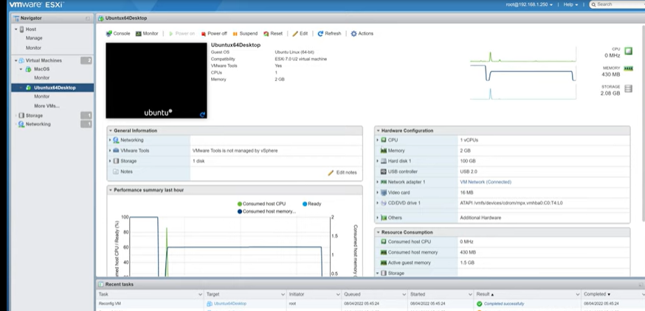

**Result:**